

300 NW 13th Avenue
Portland, OR 97209 USA
503-227-0222 phone
503-227-0008 fax
gallery@bullseyeglass.com
www.bullseyegallery.com

March 5, 2007 FOR IMMEDIATE RELEASE

Bullseye presents Jun Kaneko: New Glass

When: March 20 – August 18, 2007
Tuesday – Saturday, 10:00 am – 5:00 pm
(and by appointment)

Where: Bullseye Gallery
300 NW 13th Avenue
Portland, OR 97209 USA
View map

Artist Reception: Tuesday, March 20, 5:30 pm – 7:30 pm

First Thursdays: April 5, 5:00 pm – 8:00 pm
May 3, 5:00 – 8:00 pm
June 7, 5:00 – 8:00 pm
July 5, 5:00 – 8:00 pm
August 2, 5:00 – 8:00 pm

Portland, OR - Bullseye Gallery is pleased to announce a solo exhibition of new works in kilnformed glass by Jun Kaneko.

Representing over three years of collaboration with Portland’s Bullseye Glass factory, the project continues Kaneko’s involvement with the manufacturer that was initiated in 1997 and has resulted in the creation of a body of works in glass that are both monumental in scale and singular in their material approach.

“Kaneko is known internationally for his ceramics but is a relatively new player in the field of contemporary studio glass” says gallery director Lani McGregor. “His approach is outside the usual glass traditions, the Venetian or Czech models. It’s fresh but at the same time it continues Kaneko’s concerns with the environmental circumstances of his ceramic work.”

Most of Kaneko’s glass forms weigh hundreds of pounds each and stand taller than the viewer. Grouped throughout the darkened gallery, they afford an experience that is both ephemeral and massively grounded. A phalanx of primary-colored leaning slabs calls to mind gigantic unboxed color crayons goose-stepping across a dream field. At once playful and daunting, they confront the viewer on an almost primeval level.

While relatively conservative in size when compared to Kaneko’s famous Dangos (dumpling-shaped ceramic sculptures that stand as high as 14 feet), the glass slabs and sticks comprising the current exhibition at Bullseye required over 20,000 pounds of raw glass and over 10,000 hours of fabrication time from the factory team that executed them to Kaneko’s specifications.

“It’s been a long time coming,” reflects McGregor. “There’ve been times when it felt like we were building a memorial – and hoping it wasn’t our own!”

The exhibition includes 40 cast glass slabs and a 42-foot long spiraling wall of glass threads. Created during the project but not included in the Portland showing is a set of five multi-colored slabs that were loaned to the Victoria and Albert Museum in London shortly after completion.

Born in Nagoya, Japan, Jun Kaneko has lived and worked in the United States since 1963. He has taught at Cranbrook Academy, Rhode Island School of Design, Scripps College and the University of New Hampshire. His work is held in major museums internationally. He maintains a studio in Omaha, Nebraska.

The Bullseye Glass Company is a manufacturer of colored glass designed for artistic and architectural usage. Started by artists in Portland, Oregon in 1974, the company, in addition to its manufacturing operations, hosts a limited number of artist projects annually, offers courses in studio glass, and underwrites a gallery that showcases and sells works created by artists from the materials produced in its Southeast Portland factory.

To view exhibitions, find out more about the Bullseye Gallery and download artist statements and curricula vitae, please visit the gallery online at bullseyegallery.com.

To receive additional information, request high-resolution images, or schedule an interview, please contact Nicole Leaper by phone at 503-227-0222 or by email at nicoleleaper@bullseyeglass.com.
#
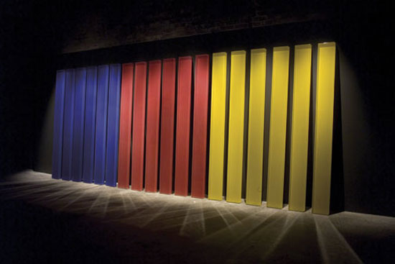
Jun Kaneko, African Reflection, Blue, Red, Yellow, 2007.
Kilnformed glass, 83 x 204 x 10.5 inches installed.

